***BENEFICIARY BIODATA FORM ***

*NAME: CHIGELU ONYEDIKACHUKWU UDOBI*

*SEX: MALE*

*DATE OF BIRTH: 01/10/2000*

*STATE OF ORIGIN: ANAMBRA STATE*

*BANK: ACCESS BANK*

*ACCOUNT NUMBER: 0804066776*

*ADDRESS:3RD AVENUE GWARIMPA ABUJA*

*BUSINESS NAME: LONGBEAK TECHNOLOGIES*

*BUSINESS DESCRIPTION: LONGBEAK TECHNOLOGIES IS A TECHNOLOGY START-UP THAT AIMS IN THE PROVIDING QUALITY SERVICES LIKE PROFESSIONAL WEBSITE DEVELOPMENT, MOBILE SERVICES AND TRAINING IN SKILLS ACQUSITION*

*SIGNATURE:*

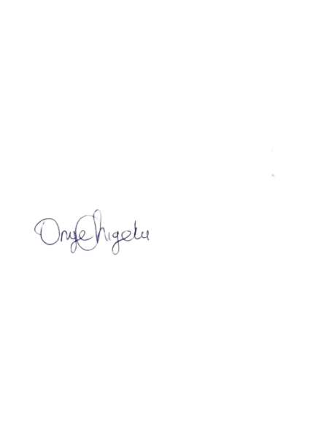

*PROOF OF IDENTIFICATION:*

